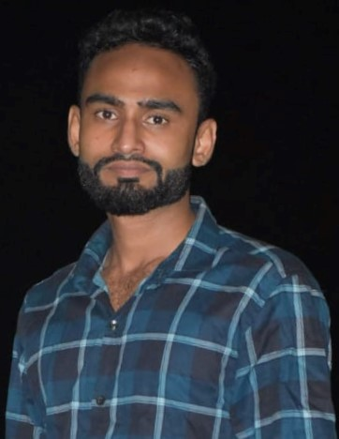Curriculum vitae

**Student at** :cumilla polytechnic institute

Dept:civil-Roll:937416-shift:2nd.

**Name**  :Mahmudul Hasan

**Father’s Name**  :Ahidur Rahman

**Mother’s Name**  :Mahfuja begum

**Present address**  : Village-Dhunoa khala Soroth Nagar

**Permanent address**  : Dhunoa khala Sarat Nagar.

**Post office**  :Soroth Nagar, post code-3501

**Zila**  :cumilla.

**Date of birth**  :19/08/2001

**Sex**  :Male

**Religion**  :Islam

**Nationality**  :Bangladeshi

**Mobile**  :01881-417939

**Education qualification**  :

|  |  |  |  |  |
| --- | --- | --- | --- | --- |
| degrees | Group | Board | Pass year | Result (GPA) |
| S.S.C | Science | Cumilla | 2017 | 4.77 |

Experience :

|  |  |  |
| --- | --- | --- |
| Company name | Designation | Duration |
| Sarwar enterprise | Site Engineer | Internship Running |

**Date** : **signature**

(Mahmudul Hasan)